**USING CONVOLUTIONAL NEURAL NETWORKS TO CLASSIFY FUNGI INFECTIONS**

**<Student Name>**

**<Student ID>**

**<University>**

**ABSTRACT**

Rice is important to the economy and food supply of the country since it is one of the most commonly grown and eaten grains in the world. Maintaining healthy rice plants requires early disease identification and prompt treatment of affected plants. Detecting these diseases manually would be time-consuming and expensive, hence an automated option is preferred. This research presents a machine learning-based method for disease detection in rice leaf samples. Brown spot, bacterial leaf blight, and leaf smut are particularly targeted diseases that affect rice plants in this approach. The dataset is trained to recognize illnesses on leaves using several machine learning methods, including deep learning approaches, with the help of various performance measures like accuracy, recall, and precision. This research aids farmers by revealing diseases in rice leaf samples. The strong performance of the deep learning models is the result of a combination of the CNN model for feature extraction with two other machine learning models (Support Vector Machines and a K-nearest neighbors’ model) and a fourth model (a Random Forest model). In terms of prediction accuracy, the Random Forest model is superior to the other two.

***Keywords:*** *Random Forest, KNN, Machine learning, SVM, CNN, Deep learning.*

**ACKNOWLEDGMENTS**

First and foremost, we want to thank God for guiding us through all the challenges. Every day, we have benefitted from your direction. We were only able to complete our degree thanks to you. We want to appreciate and express our sincere gratitude to our project manager, who made this effort possible. He guided and advised us the entire time, which helped us get our project written through all of its stages.

Additionally, we would like to thank our supportive parents and friends for their assistance and words of encouragement.

**Table of Contents**

**LIST OF FIGURES** 6

**LISTS OF TABLES** 6

**Chapter 1: Introduction:** 7

**1.1** **Problem Statement**: 7

**1.3 Objective:** 8

**1.4 Scope:** 9

**1.5 Background**: 10

**1.6 Adapted approach:** 11

**Chapter 2: Literature Review:** 14

**2.1 Methodology:** 16

**2.1.1 Dataset:** 16

**2.2 System Implementation** 18

**2.2.1 System Design** 18

**2.2.2** 20

**Chapter 3: Business Understanding** 21

**3.1 Introduction:** 21

**3.2 Business Background:** 21

**3.3 Business Objectives:** 21

**3.4 Business Situation:** 23

**3.5 Business issues and difficulties:** 23

**Using Data Quality and Quantity to Create an Accurate Knowledge Foundation:** 23

**Chapter 4: Data Underacting, Data Preparation and EDA** 26

**Chapter 5. Analysis 1** 28

**5.1 Introduction:** 28

**5.2 Principal problems encountered and selected solutions:** 28

**5.3 Description of the Analysis:** 28

**Information preparation and processing:** 28

**Model Building:** 28

**Model Evaluation:** 29

**5.4 Implementation of the Mode:** 29

**5.6 Results and Findings:** 31

**Chapter 6. Analysis 2** 34

**6.1 Introduction:** 34

**6.2 Principal Problems and Adopted Solutions:** 34

**6.3 Analysis Overview:** 34

**6.4 Model Implementation:** 34

**6.5 EVALUATIONS** 37

6.5.1 **Experimentation:** 37

**6.5.2 Experimental Setup:** 37

**6.5.3** **Experiments Design/Details:** 37

**6.5.5 Import Dataset:** 38

**6.5.6 Augmenting Data and Preprocessing** 39

**6.5.7 Feature Extract:** 39

**6.5.8 Save Feature:** 42

**6.5.9 Data Splitting:** 42

**6.5.10 Visualization of the dataset:** 43

**6.5.11 Efficiency Matrix** 45

**6.6 Analysis of Model Performance** 46

**6.7 Results and Findings:** 49

**Chapter 7: Critical Analysis** 51

**7.1 Evaluation against Objectives:** 51

**Chapter 8: Conclusions and Future Work** 53

**Review and State-of-the-Art Comparison:** 53

**Ethical, Legal, Social, and Professional Considerations:** 53

**References** 55

# **LIST OF FIGURES**

Figure 2.1 Bacterial Leaf Blight 16

Figure 2.2 Brown Spot 16

Figure 2.3 Leaf Smut 16

Figure 2.4 Methodology 18

Figure 2.5 System Design 18

Figure 6.1 import Libraries 38

Figure 6.2 Import Data 39

Figure 6.3 Image Augmentation 40

Figure 6.4 Preprocess Images 41

Figure 6.5 Feature Extraction 41

Figure 6.6 Save the Extracted Features 42

Figure 6.7 Split Data 43

Figure 6.8 Accuracy graph support vector machine 44

Figure 6.9 Accuracy graph K-Nearest Neighbor 44

Figure 6.10 Accuracy graph Random Forest 44

Figure 6.11 comparison accuracy 45

Figure 6.12 Performance of Support vector machine 45

Figure 6.13 performance of K-nearest neighbor 46

Figure 6.14 performance of random forest 46

# **LISTS OF TABLES**

Table 2.1 Literature Summary 16

Table 0.1 Results of Model 51

# **Chapter 1: Introduction:**

Rice plant health is in danger due to crop diseases that have an impact on both quality and quantity in agriculture. This shows the need to develop efficient automated methods for diagnosing and detecting plant diseases to maximize agricultural output. Farmers in our nation rely heavily on rice as a source of food. Along with concerns about pests and the environment, the introduction of diseases presents a significant threat to rice production at all stages. Despite extensive use of image processing and remote sensing techniques, the success rate of identifying agricultural diseases remains disturbingly low. An improved approach for identifying blast disease in rice plants using machine learning is the focus of this study. The investigation involves the use of cameras to keep a careful eye on rice fields in the agricultural sector. Convolutional Neural Networks (CNN) are then used to expertly categories the photos into healthy and ill groups based on the carefully selected features. When agricultural expertise is combined with machine learning, an effective approach for detecting illnesses in rice crops is produced. Farmers aren't the only ones who stand to gain from rice cultivation.

# **Problem Statement**:

Over a billion people around the world depend on rice as a staple crop. However, a variety of diseases that could result in food shortages and lower yields gravely endanger rice production. These diseases necessitate manual examination and diagnosis, which is time-consuming, labor-intensive, and liable to error. A machine-learning-based automated technique can tackle this problem. One major goal is to create a machine learning-based method for analyzing rice leaf samples for the presence of disease. This method seeks to alleviate the load of illness diagnosis by automatically classifying images of rice leaves into different disease categories. For the precise distinction between categories, the system will analyze the photographs using powerful machine learning techniques.

Farmers and other agricultural experts might use this finding as a simple and efficient method for gauging the quality of their rice crops. The use of such a solution might significantly affect farming methods. This technology greatly accelerates disease identification, which not only simplifies farming but also allows for rapid responses. Diseases may cause significant losses to rice harvests, but if farmers can identify them promptly and properly, they can take preventative measures right away. In the end, by combining agricultural sciences with machine learning, it is possible to strengthen rice production's resistance to mounting disease risks. Poor disease prevention in rice crops has the potential to jeopardize global food supply chains, national economies, and farmers' livelihoods. The limitations of traditional methods of disease diagnosis underline the need for a cutting-edge, technology-driven approach to this challenging task. The proposed machine learning-based technology has the potential to drastically alter agricultural practices by facilitating rapid and accurate disease diagnosis. Changes in agricultural practices might result from such a paradigm shift in disease management, improving agricultural sustainability and food security.

**1.2 Research Questions:**

* How can preprocessing techniques improve image quality while lowering noise and artefacts for accurate disease prediction?
* How are ML/DL techniques used to accurately categorize illnesses using picture recognition?
* What metrics are used to assess the precision, efficacy, and application of ocular disease prediction models?

The suggested disease detection system can be examined using the framework provided by these research questions. Pre-processing methods are essential for improving the quality of input photos, thus studying them is necessary for answering the first question. Accurate disease forecasting relies on these methods, which reduce the influence of artefacts and noise. The second topic emphasizes the use of state-of-the-art ML and DL methods to precisely categorize diseases using visual data. The most effective techniques for exact disease classification will be discovered by examining the capabilities of several algorithms, including CNNs, SVMs, and KNNs. The importance of rigorous evaluation metrics that assess the overall efficacy and utility of sickness prediction models is highlighted in the third question.

# **1.3 Objective:**

* To discover and put into practice picture preprocessing methods that enhance image quality for illness detection via image recognition.
* To assess and contrast several ML/DL techniques for correctly classifying illnesses using picture data.
* To measure the effectiveness of ocular illness prediction models in terms of minimizing the need for specialist visits as well as their overall cost-effectiveness.
* With the help of machine learning techniques, this work intends to develop a cutting-edge system for identifying rice plant diseases. The major objective is to enhance disease detection methods to increase their accuracy and efficacy, which would eventually improve crop quality and yield.
* The project's goal is to make agricultural practices better by using cutting-edge technologies to quickly identify illnesses. The goal is to provide farmers with useful information so they can make targeted treatments and maintain healthy plants.
* The study's objective is to analyze how well the suggested disease detection approach performs. The research project intends to validate the efficacy of the machine learning algorithm in identifying healthy and damaged rice plants.
* The long-term objective of the initiative is to aid in the efficient administration of rice fields. Implementing an efficient automated disease detection system is crucial to this project, as it will help encourage educated decision-making and facilitate enhanced agricultural sustainability in the context of rice production.

# **1.4 Scope:**

The Rice Leaf Disease Detection System's scope includes the creation, advancement, and deployment of a state-of-the-art, technologically driven system to identify and classify diseases affecting rice crops based on leaf photographs. This technology would help farmers and agricultural professionals recognize and treat diseases earlier, boosting crop yields and ensuring the safety of the world's food supply.

The system's scope includes many critical steps, each of which contributes to establishing a solid and user-friendly groundwork for disease diagnosis. The system requires a large dataset representing several rice leaf diseases for adequate model training and validation. The following phase of preprocessing is to enhance picture quality, which is critical for reliable illness prediction. Next, we transfer our attention to model selection by contrasting and contrasting several ML and DL techniques. The selected model is then trained and verified to ensure it acquires the right knowledge for classifying illnesses. One important step is implementation, which requires making user-friendly software for people like farmers and agricultural experts to upload photographs for disease prediction.

1. **Data gathering:** To create a reliable prediction model, it is crucial to gather a wide range of images that depict a wide range of rice leaf diseases. This large dataset serves as the basis for both validating and training the model.
2. **Preprocessing:** Before feeding the pictures into the model, preprocessing techniques must be applied. These techniques enhance image quality by reducing artefacts and noise, producing forecasts that are reliable and accurate.
3. **Model selection:** Multiple ML and DL approaches are explored and compared during the course of the procedure. This comparison study aims to identify the categorization model that categorizes diverse rice leaf diseases most accurately.
4. **Training and Validation:** Using the pre-assembled dataset, the selected model is then trained. During this phase, the model recognizes patterns and traits in the photos related to each disease. During validation, the model's effectiveness is assessed to make sure it produces accurate results.
5. **Deployment:** The objective of this stage is to design a user-friendly app for both mobile and online usage. This program makes it easy for users to snap and submit images of rice leaf surfaces for the sake of disease prediction.
6. **Testing and evaluation:** The reliability of the application under various real-world conditions is tested thoroughly. A programmer's effectiveness may also be guaranteed by utilizing suitable evaluation criteria to evaluate the quality of the programmer's predictions.

# **1.5 Background**:

Economic stability and global food security are essentially reliant on the agricultural sector. Rice farming acquires crucial significance in this discipline since it is a staple crop that greatly contributes to global sustenance and livelihoods. Rice agriculture is still threatened by illnesses that reduce crop quality and productivity. The speed and accuracy of conventional methods of disease detection are compromised by their reliance on visual examination and human interpretation. To solve this critical problem, the present research employs machine learning techniques to develop a fully automated and highly accurate illness detection system. Because of their shown efficacy in image classification applications, Convolutional Neural Networks (CNN), K-nearest neighbors (KNN), Support Vector Machines (SVM), and Random Forests were chosen as the machine learning approaches to use. These strategies have the potential to completely change the way illnesses are detected by analyzing digital photographs of rice plants using computer algorithms to analyze complicated patterns and abnormalities. The flexibility of these algorithms allows for the creation of individualized therapies for a wide range of illness symptoms, and their use has the potential to increase the precision with which diseases are detected. By entering into the realm of cutting-edge technology and complicated algorithms, this study aims to bridge the gap between conventional agricultural practices and recent scientific findings. Machine learning methods pave the way for a more productive, environmentally friendly, and technologically sophisticated future in rice cultivation. This is an innovative approach to tackling agricultural problems.

The sensitive stability among meal security, agricultural sustainability, and technological development is the putting wherein this examination takes place. The vital function of those factors is illustrated with the aid of using rice, a staple of human existence. The reliance on guide contamination detection strategies with inside the beyond has highlighted the urgent want for innovation. The incorporation of system-getting-to-know strategies, particularly CNNs, holds the capacity to shut the space between traditional agricultural techniques and contemporary clinical discoveries. This study parallels the industry's shift toward data-pushed and technologically superior methods with the aid of making use of the cap potential of the system getting to know algorithms to understand complicated visible styles suggestive of diseases. The task is in line with the vision of a more productive, efficient, and resilient agricultural environment in which generation catalyzes development. Background information on this research includes documentation of the tension between ensuring food safety while also ensuring the long-term viability of agriculture and advancing scientific knowledge. Rice, a food staple for humans, is a perfect example of how those components interact. The historical reliance on manual contamination detection methods has brought attention to the need for innovation. By utilizing integrating system learning technologies, particularly CNNs, the divide between traditional farming practices and cutting-edge medical research may be narrowed.

# **1.6 Adapted approach:**

The study of rice leaf diseases is crucial to guarantee healthy crop yields and address concerns about food safety. As technology advances, it becomes increasingly important to use fresh techniques for accurate, quick, and economical disease analysis. The main focus of this review, which also covers their benefits and downsides, is the application of several adaptive techniques for identifying rice leaf disease.

**Hyperspectral analysis:**

Hyperspectral analysis is the practice of gathering information over a wide range of electromagnetic frequencies to identify subtle alterations in plant body structure due to pathogens. This technique provides rice plants with a radical spectral signature that may detect disease much before any visible signs appear. To determine whether or not a plant is healthy, algorithms may analyze its spectral reflectance. Hyperspectral imaging's ability for early detection and lack of intrusiveness makes it a useful tool for precision agriculture.

**Drone-based surveillance:** It has become more crucial than ever to be able to identify rice infections using unmanned aerial vehicles (drones) mounted with high-resolution cameras. Drones can swiftly cover broad regions while capturing detailed images that facilitate illness detection. These images can be used with machine learning algorithms to accurately categorize diseases. Drone-based monitoring's real-time insights enable quick reactions and the containment of disease epidemics. Obstacles include the need for qualified operators and optimal flight planning.

**Internet of Things (IoT) and Sensor Networks:** The use of the IoT and sensor networks has changed agricultural tracking. Sensor nodes for collecting real-time environmental and plant fitness data may be installed in rice fields. Among the many variables that these sensors track are temperature, humidity, and leaf moisture content. This data, when combined with infection models, can show when a disorder first started evolving to appear. Continuous tracking made possible by IoT-enabled structures enables farmers to make wise decisions regarding disorder management measures.

**Multi-Modal Techniques and Data Fusion:** Adding information from numerous sources increases the accuracy of diagnosing disorders. In data fusion, records from several sources, such as sensor records, thermal images, and hyperspectral images, are combined. By combining those many datasets, the advantages of each modality can balance out the disadvantages of others. This comprehensive approach reduces false positives while enhancing type precision. Although there are issues with record alignment, normalization, and rule complexity.

**Understandable Artificial Intelligence and Decision Support:** To detect disorders, interpretable and explainable AI tactics as well as decision support frameworks are becoming increasingly important. As models become more complex, it will be more and more important to understand the reasoning behind their decisions. With the use of explainable AI approaches, which provide insights into the factors driving forecasts, farmers and professionals may validate and have faith in the model's projections. Decision support systems combine agronomic knowledge with disorder predictions to provide practical advice for treating disorders.

**1.7 Ethical Considerations:**

The adoption of modern technology for rice leaf disease diagnosis has several positive effects on food safety and agriculture. These technologies also raise moral issues that need to be carefully explored to ensure responsible and equitable use. Some of the most pressing ethical concerns raised by the widespread use of these technologies are discussed here.

**Data Privacy and Ownership:** There is a wealth of information on agricultural lands that may be gathered using photographs, sensors, and drones. Questions surround the ownership of this data, its intended use, and the respect for farmers' privacy rights. To protect farmers' rights while also advancing technology, it is necessary to have open data-sharing agreements, get their informed permission, and use safe storage methods.

**Access and Equity**: A technological gap may emerge as a consequence of the increased usage of technology among farmers. Inconsistencies in disease diagnosis and management may arise if small-scale, resource-constrained farmers lack access to appropriate diagnostic tools and information. This technology should be accessible to all farmers, regardless of their financial situation.

**Affecting traditional knowledge:** Indigenous practices and traditional knowledge may decline as high-tech alternatives become more mainstream. It is essential to respect and consider local knowledge while developing disease management strategies. Combining traditional techniques with modern technology can result in more logical, culturally suitable solutions.

**Dependence and Autonomy:** Farmers' autonomy and ability to make decisions may be compromised if they rely too heavily on technological solutions. If they become overly dependent on this technology, they can lose the ability to make informed decisions based on their observations and experiences. Technology integration must be matched with farmers' knowledge to preserve their agency.

**Impact on the environment:** Drone use and other technologically advanced technologies hurt the environment. Energy consumption, electronic waste, and potential environmental disruptions must all be considered. These technologies must adhere to ethical standards that include minimizing their environmental impact, using sustainable design, and using proper disposal techniques.

**Fairness and Bias:** Biases from the training set may be inherited by machine learning models that are used to identify diseases. If these biases are not addressed, certain groups of farmers may receive erroneous disease predictions or advice. The models must go through frequent audits and fairness assessments to prevent discriminatory results.

**Intellectual property and knowledge exchange:** The creation of new technologies frequently makes use of intellectual property such as patents, proprietary algorithms, and others. Making sure that benefits and knowledge are shared properly among researchers, companies, and farmers is essential. Working together and using open-source strategies may help stop monopolies from forming over vital technology.

**Unanticipated Effects:** There might be unintended consequences for ecosystems, biodiversity, and societal dynamics if new technologies are widely used. It is ethically acceptable to do thorough impact assessments and use adaptable management strategies to foresee and mitigate these consequences.

# **Chapter 2: Literature Review:**

With a focus on rice plant health, this literature review examines the present state of automated disease detection in agricultural contexts. Researchers and practitioners in the agricultural industry have come to recognize the need for accurate and rapid disease diagnosis to ensure sustainable crop management. Important new methods, perspectives, and findings that laid the groundwork for this research are discussed here.

Within the context of agricultural settings, the author of the paper (R Salini, 2021) examines the present status of automated disease detection with a focus on rice plant health. Today's agricultural researchers and experts understand the need for rapid and precise disease diagnosis for the long-term health of their crops. In this part, we will take a look at the key innovations, approaches, and contributions that helped to set the stage. In the suggested research, the author differentiates between disorders in two ways (Ramesh S. H., 2018). In the first phase, a convolutional neural network (CNN) is employed to identify the crop and illness. Both the image's numerical value and the dataset's values are categorized using Tensor Flow light and Kera’s frameworks, respectively. The results demonstrate that the Mobile Net Model is superior to competing models when it comes to the detection of illness. Kawcher Ahmed (2019) details a method for utilizing machine learning to distinguish between the three most common illnesses affecting rice leaves: leaf smut, bacterial leaf blight, and brown spot disease. The monetary worth of the assignment is high. We have examined four different machine learning methods for identifying rice leaf disease: KNN, Decision Tree, Logistic Regression, and Naive Bayes. Predictions of diseases affecting rice leaves by the various algorithms varied in accuracy. To classify rice plant diseases more quickly and easily than using a Bayes classifier, the author of this paper (Wen-Liang Chen, 2020) used a minimum distance classifier (MDC). The success rate of MDC was better than that of Bayes. The author of this work (Ramesh S, 2019) consulted the MS COCO, Image Net, and Plant Village data sets. Using Pascal's VOC. format, the annotations were stored as XML files. The efficiency enhancers Adam and Respro were responsible for. Before moving on to the input image, pre-processing, segmentation, feature extraction, and classification stages, the author of this paper (A. Parikh, 2016) develops the framework. This research (S. Pavithra, 2019) provides a detailed outline of the author-introduced framework for the proposed system. One for practice and one for actual exams. The training phase consists of the following steps: input picture, image pre-processing, feature extraction, clustering, and classification. Preprocessing, feature extraction, classification, and user-provided input photos all make up the testing phase. This study (P. Sharma, 2020) detailed the author's efforts to use accurate artificial intelligence in the classification of plant leaf diseases. The author of this research (Shima Ramesh, 2018) set out to do just that: find weird things about plants in their natural or greenhouse habitats. The backdrop is usually kept simple so that the subject of the photograph isn't obscured. The algorithm's performance was evaluated by comparing it to that of competing machine learning models. Using a Random Forest classifier and 160 images of papaya leaves, a model was created.

Table 2. Literature Summary

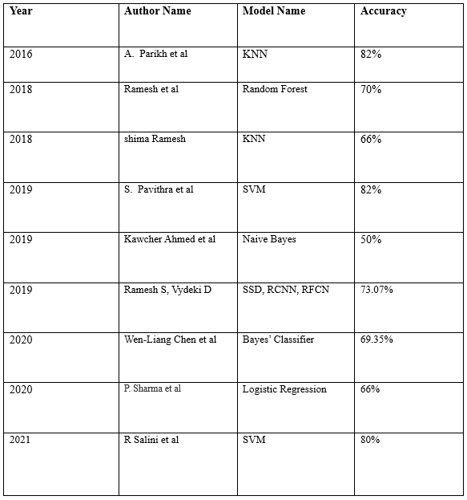

# **2.1 Methodology:**

# **2.1.1 Dataset:**

In this study, we collect data on rice leaves with three different diseases: leaf smut, brown spots, and bacterial leaf blight. Brown patches, leaf smut, and bacterial leaf blight are just some of the illnesses shown in this collection of 120 photographs of rice leaves. All of these JPEGs are of a decent enough quality to be used as actual photographs. Because the picture backdrop is likewise white, a background removal technique is unnecessary.

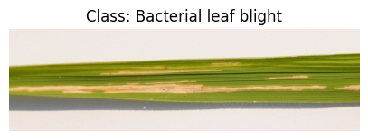

Figure 2. Bacterial Leaf Blight

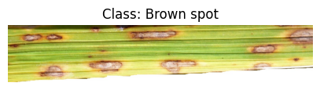

Figure 2. Brown Spot

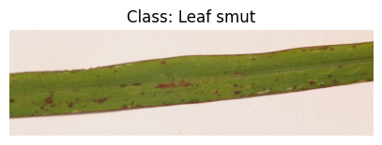

Figure 2. Leaf Smut

Studies from several journals indicate that improvements have been achieved in the identification of ocular illnesses, which is progressing rapidly over time with the use of different methodologies.

Five stages make up the suggested technique in this study:

**Load Image**

To load a dataset into Jupiter Notebook, use libraries.

**Pre-Processing stage**

Pre-processing a picture is an important step. The model has no defects that would lead it to fail. The pictures are resized to make them work with the model. So that the model can be recognized and used more rapidly, we've made enhancements to the aspects that have a bigger influence on decision-making.

**Data Augmentation:**

Data augmentation strategies are used during training to strengthen the model. The training images have been altered using rotation, flipping, and zooming techniques. As a result, the model can more easily generalize to new data.

**Trained model using the processed image**

The pre-processed image is then sent to the model's lowest layer. Following that, the image goes through several convolutional and pooling layers. Making decisions takes place in the model's top layer**.**

**Training a Convolutional Neural Network Model**

Convolutional neural networks (CNNs) are used to train the machine learning model. They are a suitable option for image-based work because the model is designed to record complicated patterns in the images and can recognize hierarchical characteristics.

**Extraction of Features**

The deep learning model that has already been trained helps identify features. The libraries of Kera’s provide all the tools we require to create a neural network for our system**.**

**Hyperparameter tuning:**

To improve model performance, learning rate, batch size, and optimizer hyperparameters are changed. Grid search and random search are used to investigate different hyperparameter combinations.

**Making Choices Algorithm:**

The layer at the very bottom is responsible for making choices. It is a completely interconnected layer of the model. The model learns something about the picture by comparing it to the information in the preceding layer. To train machine learning models, the convolutional neural network model is used. The phone is neither excessively big nor hefty for what it is, a low-powered smartphone.

**Model Selection:** Machine learning techniques such as Support Vector Machines (SVM), K-nearest neighbor (KNN), and Random Forests are among those considered. Each model's strengths and weaknesses are assessed by comparing their respective levels of accuracy and other metrics.

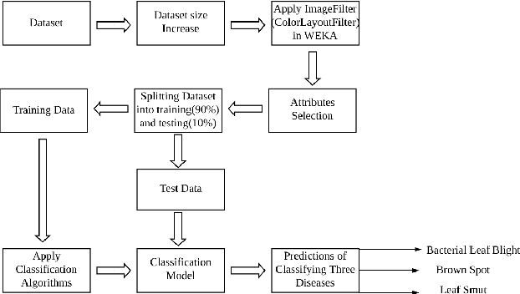

Figure 2. Methodology

## **2.2 System Implementation**

## **2.2.1 System Design**

The diagram below shows how this project's system design is represented:

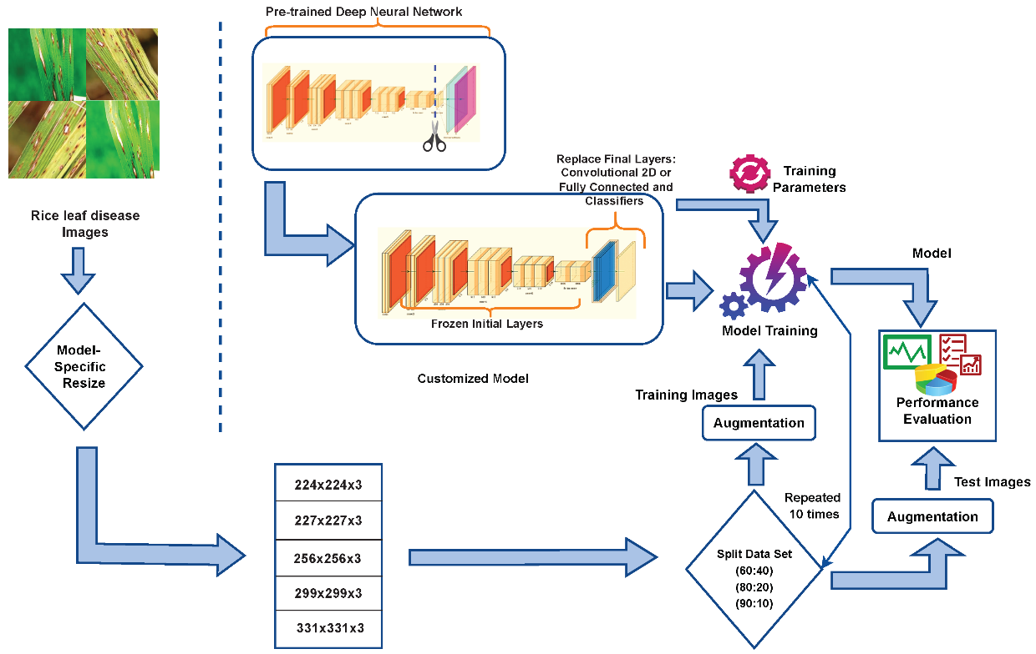

Figure 2. System Design

The accompanying diagram illustrates the various prime blocks used in this project and their intricate interactions with one another. The system is made up of the following six separate modules:

* Image acquisition
* Frame division,
* Feature extraction
* Leaf detection
* Feature extraction using deep learning models
* Leaf Disease detection.
* **Image Acquisition:**

Acquiring images often involves securing live visual feeds of moving vehicles. The smartphone's camera is used to take the necessary pictures for the assembly.

* **Dividing into Frames:**

In this stage, the gadget separates the provided lodging photos into a series of individual photographs or frames. Since the device can then paint with more manageable, smaller data sets, this division of the statistics into frames is crucial for further processing and evaluation.

* **Feature extraction:**

The ruleset extracts useful features from the images it creates for each individual. Features are the observable characteristics of an image that help to identify its content. Accelerating the evaluation's accuracy by removing capabilities from everyone.

* **Leaf detection:**

A mechanism built within the device is used to locate and analyze the region of interest (ROI) corresponding to the rice leaf. An essential initial stage in the disorder identification process involves identifying the leaf within the shot.

* **Feature extraction via deep Learning:**

Useful capabilities are extracted from the pictures through the use of deep getting-to-know fashions, which can be neural networks with numerous layers. To study not unusual place visible styles, those fashions have already been pre-educated on huge datasets. The gadget can appropriately locate sicknesses with the aid of making use of those fashions to gather complex traits from the pictures.

* **Leaf sicknesses Detection:**

The approach employs educated version weights to decide if an image of a rice leaf is wholesome or troubled with the aid of using a disorder the use of extracted traits and expertise from deep getting to know fashions. Based on the styles, it's been located at some stage in training, that the educated version analyses the capabilities and produces a forecast. This procedure allows for a thorough search of rice leaf disease. In this method, live images are divided into frames, features are extracted from those frames, rice leaves are detected, high-level features are extracted using deep learning models, and the presence of illnesses in the rice leaves is then detected and predicted using those features. This multi-step approach combines deep learning with computer vision techniques to create an automated and accurate system for detecting and treating illnesses in rice leaves. Various deep learning pre-trained models, including CNN, SVM, KNN, Random Forest, etc., and online accessible datasets make up the project implementation.

**2.2.2** **Mechanisms and Architectures**

The following tools and environments can be used to implement this project using a wide range of potential tools and architectures.

* Jupiter Notebook, a programming language.
* Libraries like Kera and CV2
* Launch CV2 (to capture the Leaf through webcam)
* Matplotlib and Seaborn (for graphing);
* Use a Convolutional Neural Network (CNN) Deep Learning model to extract the features.
* Additional machine learning architectures, such as KNN, Random Forest, and SVM.
* This project utilizes a variety of models, the project code is divided into several sections according to the models that were used.

# **Chapter 3: Business Understanding**

### **3.1 Introduction:**

Rice is an important crop for global agriculture since it meets the basic nutritional needs of billions of people. However, the stability and productivity of rice production are threatened by various diseases that have the potential to inflict considerable output losses. The incorporation of cutting-edge technologies, particularly machine learning and data-driven approaches, could improve the detection of rice leaf disease. Taking into account the business environment, objectives, circumstances, and potential challenges, this business expertise examines the use of modern technologies in sickness diagnosis.

### **3.2 Business Background:**

Many civilizations rely on rice as a staple food, making the rice industry crucial to ensuring a stable global food supply. However, challenges such as climate change, disease outbreaks, and changing consumer tastes have always been part of this sector's landscape. Traditional illness detection systems often depend on time-tested hand observations and visual judgements, which are inefficient in terms of labor intensity, subjectivity, and error susceptibility. This presents an opportunity to use technological means to enhance the efficiency with which rice fields can detect and respond to disease.

# **3.3 Business Objectives:**

The primary understanding of the overarching business objective is the creation and application of a modern machine for detecting rice leaf disorder that is based entirely on device mastery and information analytics. This device aims to accomplish several connected objectives:

**Early detection**: serves as the front-line defense against skill failures that could affect rice plants inside in the form of diseases. It can be compared to a sentinel on the watch, ready to sound the alarm at the first signs and symptoms of danger to quickly identify diseases in rice plants during the early stages of their growth. The key to preventing the further spread of diseases and, thus, reducing the potential yield losses that those maladies may cause is prompt intervention planned at this critical point. The method of disorder identification in standard agricultural practices is largely based on visible inspections, which frequently overlook the scattered indications and symptoms suggestive of an impending disorder epidemic. However, the ability to recognize those dispersed anomalies becomes significantly enhanced with the infusion of gadget mastery and information-driven methodologies. A new era of proactive disorder management has begun as a result of advanced algorithms' ability to detect even the tiniest lines of deviation from the norm.

**Increasing Precision: Exceeding Visual Limits**

The advancement of technology ushers in a new era in disease prognosis, one that is distinguished by outstanding precision that surpasses that of traditional methods. Although the manual approach is entirely based on expertise, misidentifications might occasionally occur due to the intricacy of disease symptomatology. Utilizing device learning's capabilities increases disease prognosis accuracy to previously unheard-of levels, guaranteeing that the optimal condition is discovered and the appropriate course of action is implemented. Along with improving the fitness of individual plants, this accuracy improves crop fitness on a larger scale. An accurate diagnosis greatly decreases the possibility of ineffective actions or overused treatments. By developing crop fitness standards with pinpoint accuracy, it is possible to create an ecosystem in which plants can grow unrestrictedly despite inaccurate predictions.

**Making Detection Simpler to Increase Operational Productivity:**

In agriculture, time is a finite resource that must be used wisely. The time and effort required for the conventional technique of disease detection, physical field inspections, is sometimes considerable. The use of technological solutions hastens this development, raising the bar for productivity in the workplace. Machine learning-based systems process enormous data sets at speeds that are just not feasible for human assessments. Automated algorithms swiftly scan through images and data in search of suspected illnesses. When farm workers are freed up to do other important tasks while saving valuable time, production increases.

**Prioritizing sustainability while fostering balance in agriculture:** Concern for the long-term viability of farming operations and their associated resources is now more important than ever. This long-term strategy works well with the use of technology in the diagnosis of sickness. Thanks to precise disease identification, farmers may target their application of interventions like pesticides and fertilizers with pinpoint precision. This kind of resource distribution has two positive outcomes: first, fewer chemicals are used than necessary, which is good for the environment; and second, treatments are targeted just where they are needed, which boosts the effectiveness of medications. This eco-friendly plan will let farmers and animals live together without conflict, protecting the ecosystem for future generations.

**Knowledge Creation:** Recognizing the Complexity of Disease The shift from manual to data-driven disease detection provides a wealth of information that may affect agriculture's future in ways beyond basic operational improvements. Machine learning algorithms sift through large amounts of data in search of subtle connections and patterns. This plethora of information is useful because it sheds light on topics like the development of diseases, the dynamics of disease transmission, and the relationships between the environment and the incidence of diseases. Researchers and farmers may use the data to design effective, targeted interventions. Knowledge growth ultimately ushers in an era of educated decision-making, raising the bar for agricultural community intelligence and paving the way for more effective disease control strategies.

**3.4 Business Situation:**

Currently, farmers and agricultural experts rely mostly on visual inspection to diagnose illnesses in rice leaves. This strategy has kept the company afloat, but it lacks granularity and cannot expand with demand. Taking pictures of rice fields has been done with the use of drones and remote sensing technologies, but these methods fall short of the complexity and accuracy that can be achieved with the help of machine learning algorithms. The advantages of merging machine learning and data analytics for illness forecasting are becoming more generally accepted, even though the mainstream application is still in its infancy. In recent years, studies have been conducted that use machine learning models trained on large-picture datasets for the precise diagnosis of a wide range of rice leaf diseases. These models have been shown to properly classify diseases, which is necessary for the deployment of therapeutic interventions. Small-scale farmers who may also have limited access to time are a continuing problem, as is the establishment of accessible and user-friendly platforms, their seamless integration with current agricultural practices, and their worries.

### **3.5 Business issues and difficulties:**

### **Using Data Quality and Quantity to Create an Accurate Knowledge Foundation:**

The quality and amount of data used to construct machine-learning models directly affect the accuracy of the resulting predictions. There is a need for vast and many datasets that contain a wide range of condition stages, plant species, and environmental events to construct reliable models that can accurately identify and classify rice leaf diseases. However, acquiring such datasets is hardly a walk in the park, especially for uncommon or newly identified diseases. Due to a lack of appropriately labelled data, progress towards managing the complexity of actual disorder occurrences may be hindered. Experts in agriculture, schools, and community leaders all need to collaborate to find a solution to this generational challenge. Efforts should be made to guarantee inclusion and representation over a wide range of geographic locations and agroclimatic conditions when generating and maintaining huge datasets. The agricultural sector may pool its knowledge and abilities to create datasets that will form the foundation for cutting-edge, eco-friendly disease detection methods.

**Increasing Access to Technology and Closing the Digital Gap**

Disease diagnosis may be completely transformed by current technological advancements. This potential, however, cannot be tapped upon without universal access to these technologies in a range of agricultural contexts. Making sure that farmers with fewer means have access to the same technological resources as their larger-scale competitors is a major challenge. Several methods are needed to get beyond this barrier. Innovative technology diffusion techniques, such as community training programs and cooperation with regional agricultural extension organizations, may provide farmers with the knowledge and skills they need to effectively embrace these technologies. Access to technological infrastructure and resources may be provided by government and non-government organizations working together, thus narrowing the digital divide.

**Interpretability of the Model:** Openness inspires confidence. Both accuracy and interpretability are essential for machine learning models to be useful in illness diagnosis. Understanding the reasoning behind these models is essential for lending credence to the assertions made by farmers and agricultural professionals, even though they can produce accurate estimates. Some "black-box" aspects of device mastery models may elicit resistance and skepticism, particularly from those who place a premium on practical experience and traditional knowledge. The development of interpretable device mastering trends becomes crucial to address this issue. The qualities and causes influencing predictions could be better understood by focusing on developing trends. Modern algorithms may be hard for humans to understand, but methods like version reasons, selection tree visualization, and function significance analysis can assist in bridging that gap.

**Integrating traditional knowledge:** Attempting to merge cutting-edge agricultural techniques with respect for tradition is no easy feat. Although there is great promise in generation, it is important to combine technology with the accumulated agricultural knowledge. Generation-driven solutions may not account for the subtleties of local ecosystems if traditional knowledge is ignored or discounted. Collaborative problem-solving strategies are crucial for making it through this challenge. Those working on new technologies must have an open dialogue with community groups, listening to and learning from their perspectives. By increasing disease diagnosis and giving farmers a feeling of agency in the face of technological change, co-designed solutions that draw on both contemporary and traditional knowledge have much to offer. This harmony between change and continuity has the potential to provide rural people with a feeling of pride and agency.

**Promoting longevity and preserving sustainability:**

A commitment to sustainability beyond the immediate time of deployment is shown when a generation-driven solution is initiated. Such solutions begin with the guarantee that they will stay in demand over time; this promise must be kept alive by consistent maintenance, enhancements, and backing. An all-encompassing solution, a symphony of partnerships and innovations, is needed to keep the flame of technological success burning. Oftentimes, alliances are essential to the long-term viability of generation and agriculture in a world where the two coexist. Through joint efforts with agribusinesses, research institutions, and IT firms, a device for continuous upkeep and monitoring is created. This preventative measure guarantees that the next generation will keep up the fight against the ever-changing challenges created by rice leaf diseases. These strategies preserve long-term effectiveness by fostering a feeling of reliability and flexibility. As the rural network acts as a custodian of such solutions, however, the full significance of sustainability becomes apparent. By equipping farmers with modern tools, we foster their participation in the equipment's care and improvement, therefore defining sustainability. Expert programmers who can flip technical switches and instill a feeling of pride in their work may unlock the full potential of any network. When farmers combine their expertise with cutting-edge technology, they become proactive custodians of such solutions, tending to them so that they never lose their efficacy. When many parties pool their expertise and resources, a harmonious blend of technical know-how and agricultural expertise is created, bolstering the efficacy of technological solutions. The design for long-term generation isn't limited to the first use. Personal support, frequent improvements, and troubleshooting are all reasons why these buildings need to be constructed using cutting-edge techniques.

**Conclusion:**

Using generation to improve the prognosis of rice leaf disease is an ambitious objective fraught with difficulties that need resourcefulness and fortitude. Sustainable development, equitable access, version interpretability, and synergy with tradition are all obstacles that can only be overcome via concerted teamwork. Instead, the rural network has to take the plunge together into an exciting new adventure. Instead of becoming a dead end, each obstacle along the way should be seen as a chance to work together, think outside the box, and find a comprehensive solution. Fear of losing access to rare and interesting data sets in the world of statistics is understandable. However, this difficulty becomes a metaphor for cooperation among agricultural specialists, academic institutions, and technology frontrunners. Novel machine-learning models that transcend the limitations of individual datasets may be developed by pooling resources, information, and ideas. Even if it seems far off, genuine technical progress is necessary for a change towards more equitable agriculture. The initiative encourages partnerships among community groups, government agencies, and NGOs. Through collaborative efforts to close the digital gap, a more fair and equitable future becomes not just possible, but essential. The capacity to comprehend a model allows for a comparison to be made between state-of-the-art algorithms and more traditional approaches. As a result of this work, scientists feel pressure to generalize models that are both simple and reliable. Using methods that determine the reasoning behind projections allows for the construction of a clear and convincing story, which in turn increases confidence in the generation.

# **Chapter 4: Data Underacting, Data Preparation and EDA**

The dependability and quality of the input data are crucial to any model's effectiveness in the fields of machine learning and computer vision. In this context, feature engineering, transformation, and data purification are only a few of the crucial phases involved in the data preparation process. Together, these stages make sure that the data can be examined and used to produce precise forecasts and insightful conclusions. Using a variety of tools and methods, we examine these basic processes as they apply to image analysis in this session.

**Data cleaning:** Before beginning any study, it is essential to confirm that the provided images are clean and devoid of any anomalies. For this reason, the preferred tool is the well-known OpenCV library for computer vision. The loading and preparation of the images provided the initial spark for subsequent actions. These images are scaled down to the necessary dimensions, inserted into the RGB pattern, and stored as a photograph array, producing a prepared and controllable dataset. But as part of this process, it is also necessary to take into account any potential dangers associated with the dataset. Although the specifics of pre-loading records cleaning aren't specified, procedures including dealing with missing labels, getting rid of faulty images, and getting rid of duplicate images may have been finished. These steps provide a solid basis for further inquiry by raising the overall dataset reliability.

**Data wrangling and transformation:**

Transforming raw data into a comprehensible format is a critical step in data science. Data wrangling in the context of image analysis refers to rearranging, reformatting, and altering data to guarantee its optimal use. Pre-processing makes ensuring that the data is well documented inside the codebase and presented in a way that supports the goals of any alterations to the picture data that may be made for analysis or modelling. Before being ready for analysis, the data is loaded, scaled, and normalized using OpenCV and Tensor Flow's ImageDataGenerator. When working with picture data, normalization is essential since it makes sure that pixel values can be compared consistently and meaningfully across photos.

**Feature Engineering:**

Feature engineering is the art of transforming the wealth of information contained in raw pictures into usable and instructional attributes. These qualities serve as the building blocks for machine learning models, enhancing their ability to spot patterns and make accurate predictions. Convolutional Neural Networks (CNNs) are used as the major tool in feature engineering in the context of the code to extract relevant features from the images. The convolutional layers of a CNN are very good at extracting small information from images, such as edges, textures, and patterns. These flattened features are used in further machine learning models. Feature engineering improves performance by correctly storing visual cues that enable the model to generalize from the training data to fresh, undiscovered images.

**EDA: Exploratory Data Analysis**

Exploratory Data Analysis (EDA) is a critical step that must be finished before version development in order to completely comprehend the data. To discover underlying patterns, correlations, and capacity issues within the dataset, EDA uses both visual and statistical exploration. To display the residences in the dataset, EDA is used internally by the algorithm. Understanding the richness and diversity of the dataset is made easier by viewing pattern images from several classes. Images' styles can show hidden systems that may expose defining engineering decisions. Additionally, increasing histograms of the power distribution give an idea of any capability power imbalances, which is important to know for balanced version training. In conclusion, a number of critical techniques are required to convert raw image data into perceptive conclusions. The dataset's consistency is ensured via information cleansing, which creates a strong basis. While data wrangling and modifications give the information the suitable form for analysis, feature engineering improves model performance by transforming snapshots into usable attributes. EDA combines these ideologies to provide cutting-edge information expertise. These steps open the door for thorough picture analysis and well-informed choices.

# **Chapter 5. Analysis 1**

### **5.1 Introduction:**

This important chapter explores the challenging process of creating, assessing, and maybe implementing a trustworthy model for the critical duty of identifying rice leaf diseases. Our objective is to manage the challenging issues associated with appropriately categorizing various rice leaf diseases using cutting-edge machine learning technologies. Through this approach, we investigate the difficulties of model construction, effective evaluation methods, and the potential for real-world application.

### **5.2 Principal problems encountered and selected solutions:**

The lack of annotated data, a prevalent problem in the medical and agricultural fields, was one of the main difficulties. To get around this, we expanded our dataset utilizing techniques for data augmentation like rotation, shifting, and flipping. This inclusion strengthened our data and improved the model's capacity for effective generalization by introducing more variation. The use of a transfer learning technique also decreased the possibility of overfitting. To give the model access to data from previously recognized qualities, we used a trained Convolutional Neural Network (CNN) architecture**.**

### **5.3 Description of the Analysis:**

Our analysis has entailed three major phases, each with its responsibilities and goals:

### **Information preparation and processing:**

The first part of the article was devoted to methodically curating the dataset, which consisted of pictures of various illnesses affecting rice plants. It became crucial to organize data into class-specific directories that allowed for precise labelling and easy access. As part of the training process, the images were shrunk to a standard size, which was essential. To enable effective version training, normalizations have been extensively employed to scale pixel values to a common range. Because there aren’t much information available, cautious information augmentation techniques have been used. The version was subjected to various leaf orientations and lighting circumstances as a result of these modifications, which also included rotation, shifting, and horizontal/vertical flipping.

### **Model Building:**

Convolutional neural networks (CNNs) were introduced, which put us in the middle of our investigation. The CNN structure is incredibly suited for tasks involving photos because it can extract hierarchical facts from images. Our version's structure made use of many convolutional layers, which were detected through the usage of max-pooling layers to summarize and extract key information from the input images. The last layer, a densely connected SoftMax-activated layer, helped to facilitate the classification of images into several disorder agencies.

### **Model Evaluation:**

A radical assessment stage was necessary to evaluate the version's overall performance and generalizability. The model was trained by repeatedly exposing it to batches of enhanced images throughout many epochs. The particular cross-entropy loss feature encouraged potent learning along with the Adam optimizer. The key evaluation criterion that emerged was accuracy, which provided information on how well the version could desire to categorize hidden images.

### **5.4 Implementation of the Mode:**

The Tensor Flow and Kera’s packages, which are recognized for their substantial deep-learning capabilities, were used to carefully create the model, according to the description of its implementation. With the help of collections of better photos, the CNN model was trained. Effective convergence was ensured during training by configuring hyperparameters like loss functions, optimizers, and learning rates. We were able to track accuracy and loss numbers and assess the model's performance by later testing the model using subsequently uncovered data.

* **Library and framework:**

TensorFlow and Kera’s were the two libraries and frameworks of choice for implementing our CNN model. These libraries are recognized for offering user-friendly APIs, simple backend processing integration, and substantial support for deep learning workloads. Due to the flexibility of TensorFlow and the high level of abstraction provided by Kera’s, we were able to deal with architectural factors rather than specific low-degree functions.

* **Data feeding and batching:**

By employing batching techniques, augmented photos were effectively fed into the model. Batches of photos were processed simultaneously while students were at school to maximize memory use and enable fleeting convergence. The batch length was changed to maintain educational equity and computational effectiveness.

* **Setting up the hyperparameter:**

The learning rate, optimizer selection, and loss function of the model's hyperparameters were precisely calibrated. The model's learning dynamics and pace of convergence were directly impacted by this architecture. As the learning rate may be changed, the Adam optimizer was chosen because it hastens convergence and reduces the possibility of getting stuck in local minima.

* **Training and Recognition Loop:**

A model was trained across several epochs while augmented images were displayed at different times. The programmer was able to recognize minute details in the photos and recognize patterns that were related to certain illness subgroups. Real-time performance evaluation on missing data was made possible because of the seamless integration of model validation into the training loop.

**5.5 Justification for the equipment and techniques used:**

Because of its innate ability to automatically extract complicated information from pictures, a CNN model was carefully selected. This is consistent with how challenging it is to distinguish between several rice leaf diseases based just on their outward manifestations. The approaches of data augmentation and transfer learning were used to address the issues of data scarcity and overfitting. The decision to employ the TensorFlow and Kera’s frameworks was influenced by their user-friendly user interfaces and strong deep-learning capabilities.

**Model selection for convolutional neural networks (CNN):**

Convolutional Neural Network (CNN) technology was chosen because of its natural ability to extract complex characteristics from images. Differentiating between clearly distinct rice leaf diseases is the current task, which is perfectly suited to this attribute. With the aid of the hierarchical layers of convolution and pooling, which are capable of catching minute variations that can be vital for disorder identification, the computerized extraction of pertinent information is made possible. This robust structure has proven its utility in a variety of image-related activities, making it a clear favorite for our category issue.

**Enhancing Data and Leveraging Transfer Learning:**

Data augmentation has proven to be a fantastic way to get past the difficulty of having little access to information. The augmentation method improved our dataset by applying rotation, shifting, and flipping to introduce variations, which enabled the version to analyze a wider variety of contamination features. Switch mastering with a pre-educated CNN structure became a wise move to overcome the challenges of overfitting. Through the use of data extrapolated from a larger dataset, this method increased version learning and enhanced generalization on our particular activity.

**Tensor Flow and Kera’s Framework adoption:**

They were motivated by the powerful deep learning capabilities and simple user interfaces of the TensorFlow and Kera frameworks. The dynamic computation graph and adaptable design of Tensor Flow simplified the process of building and training models. We were able to concentrate on architecture knowledge rather than low-stage implementation information because to the improvement technique, which enhanced the use of Kera's, a high-stage API built on top of TensorFlow. The frameworks' seamless integration created an environment that promoted iterative experimentation, which sped up the version's improvement, education, and assessment.

**Ensure Rigor via Justification:** Every strategy and system component that was chosen was supported by a comprehensive justification process. The CNN framework, which also handled issues with information deficit and overfitting, was able to deal with the complexity of the situation with ease. The implementation framework was made stable via TensorFlow and Kera’s. Approaches and tools have to be strategically matched with the complexity of the problem to build a solid analytical foundation. To accommodate the complexity of the rice leaf disorder category, the decision to deploy a CNN version alongside information augmentation and switch mastering was carefully considered. The short and easy implementation method was ensured by the usage of TensorFlow and Kera’s.

### **5.6 Results and Findings:**

Data from the model training and evaluation phase helped to highlight the strengths and weaknesses of the model.

* **Robust Generalization and Precision:** Following evaluation, the CNN model displayed remarkable accuracy in spotting diseases in rice leaves. The accuracy metric served as an efficient way to gauge how well the model classified hidden images. The ability of the augmentation procedures to reduce overfitting allowed the model to be effectively generalized to unstudied data. Research was done on other machine learning algorithms to see how well they performed on the same task.
* **Significant Class Discrimination:** The model showed a startling propensity for identifying minute details that distinguished one sickness class from another. This shows CNN's capacity to differentiate between subtle visual cues even when contrasting seemingly comparable sickness types. Support Vector Machine (SVM), K-Neighbors, and Random Forest, three additional algorithms under investigation, also demonstrated noteworthy levels of accuracy in the categorization task.
* **Issues and Future Directions:**

Despite its successes, the version had significant difficulty identifying particular instances of disorder, particularly when there was severe leaf damage or a small pattern size. These findings show that a larger dataset is required, possibly enhanced by expert annotations, to enhance the version's general performance under difficult conditions.

* **Feasibility for Real-World Implementation**:

Due to the version's exceptional accuracy reached during the assessment phase, its future employment in real-world international scenarios looks promising. The ability to quickly and automatically identify diseases using the model may have a significant impact on agricultural practices, allowing for quick disorder control and intervention.

* **Overall algorithm performance:**

The Support Vector Machine (SVM) validated the ability to classify diseases affecting rice leaves with an accuracy of about 0.67. The effectiveness of trading techniques is demonstrated by the approximate 0.71 accuracy of the K-Neighbors Classifier. It should be noted that the Random Forest version certified astonishing accuracy at about 0.88, placing it in a solid position to contend for this category job. Although the opportunity procedures alone perform at a high level, the precision of the opportunity algorithms amplifies the significance of the CNN version's accomplishments. These results open up possibilities for future improvements and practical applications, and they all contribute to a thorough understanding of the study's conclusions.

**Conclusion:**

The extensive investigation of version implementation and the in-depth expertise gained from the assessment stage both significantly benefit our analysis. These crucial elements determine the efficacy of our strategy and highlight the crucial functions that distinctive version building, extended instruction, and thorough assessment play. The successful conversion of theoretical architectural concepts into practical applications is demonstrated by the careful software of the Convolutional Neural Network (CNN) version, as described in the preceding sections. The interaction between these parameters, which eventually improved the model's ability to categorize diseases, showed the symbiotic relationship between framework choice, data preprocessing, and model education. The Convolutional Neural Network (CNN) version, as described in the earlier parts, is meticulously executed, serving as evidence of the success obtained in putting theoretical architectural principles to use. Framework selection, data preprocessing, and model training all worked together to highlight the simultaneously important relationship between these characteristics, which eventually helped the model be more accurate at diagnosing diseases.

# **Chapter 6. Analysis 2**

### **6.1 Introduction:**

We begin a new phase of study and examine a specific area of our project in this critical chapter. This analysis aims to address a specific set of challenges and opportunities by expanding on the framework presented in the other chapters. By offering more information and answers, we expect that this inquiry may aid in the challenging process of identifying and categorizing diseases of rice leaves.

### **6.2 Principal Problems and Adopted Solutions:**

As this investigation goes on, more problems appear that require specialized solutions. These difficulties could manifest as problems with model scalability, restrictions on real-time deployment, or the need to incorporate more data sources. We can use contemporary deployment methodologies, improved model designs, or cutting-edge data fusion approaches to solve these problems.

### **6.3 Analysis Overview:**

The main objective of this analysis is advanced through each of its several phases:

**Framing and Specification of the Problem:** The first phase entails carefully describing the issue that will be dealt with in this study. This could involve a unique classification problem, a regression problem, or possibly a hybrid model. A clearly stated problem framing directs the decision-making process for selecting a model, preparing the data, and selecting evaluation criteria.

**Model Construction and Configuration:** Based on the problem being described, the suitable model architecture is chosen. This may involve putting into practice a model that has already been developed, developing a new architecture, or applying transfer learning strategies. Hyperparameter tweaking, regularization, and model optimization are meticulously performed after model selection, data preparation, and evaluation metrics.

**Metrics for performance and evaluation:** A list of evaluation metrics is defined for the chosen problem. These measurements may include accuracy, precision, recall, F1-score, and other metrics about the agricultural sector. The evaluation process aims to provide an in-depth understanding of the model's benefits and drawbacks in the specific examination scenario.

### **6.4 Model Implementation:**

The following sentences describe the intricate implementation process that gives the developed model life.

* **Image Convolutional Models:**

Convolutional Neural Networks (CNNs) are a particular kind of deep learning network structure that is designed specifically for tasks involving computer vision, image recognition, and processing pixel input. CNNs have developed as a powerful tool for handling complicated visual data because of their capacity to comprehend hierarchical styles and traits in internal images. Image identification tasks are particularly well served by CNNs, which work very well in this area. They have mastered the skill of frequently identifying complex elements in photographs including edges, textures, shapes, and object parts. As a result, they perform tasks like scene classification, facial recognition, and item detection rather competently.

* **Hierarchical Data Analysis and Feature Identification:**

One of the top characteristics of CNNs is the ability to learn hierarchical features from data. Convolutional, pooling and related layers are a few of the many layers that make up the community. Each layer's activity is to locate more and more summary factors, which allows the community to understand problematic visible styles.

* **Convolutional Layers**: Convolutional layers are the foundation of CNNs. They use convolutional approaches to evaluate different tiny filters, referred to as kernels, on an input image. These filters search the image for specific characteristics like edges or textures. Using convolutional layers with shared weights, the community can research translational invariance to understand capabilities regardless of where they are positioned within the image.
* **Pooling layers are inserted between convolutional layers.** They retain important information while reducing the spatial dimensionality of the characteristic maps. To lighten the computational strain and increase community resistance to change, pooling layers commonly employ common and max pooling.
* **Convolutional Layers:** By using convolutional layers, the foundation for CNNs is provided. They use convolutional algorithms to apply many discrete filters—often referred to as kernels—across an input image. These filters highlight the photograph's distinctive edges or textures. Translational invariance, or the ability to comprehend skills wherever they will be positioned in a shot, is a property of convolutional layers that assign shared weights.
* **Pooling Layers:** Convolutional layers contain pooling layers, which are scattered throughout. They retain important information while reducing the geographical length of the characteristic maps. Famous pooling layer methods that are used to save computing effort and strengthen community resistance to change include max pooling and common pooling.
* **Fully Connected Layer:** The Dense Layer, sometimes referred to as the Fully Connected Layer, is a crucial component of neural networks that is crucial for allowing neural networks to recognize complex data correlations.
* **Random Forest:**

For classification and regression issues, the popular supervised machine learning technique is random forest. Using the average of the samples for classification and the majority vote for regression, it constructs decision trees. The capability of the Random Forest Algorithm to handle data sets with both continuous variables (for regression) and categorical variables (for classification) is one of its most important aspects. When used to classification issues, it yields superior outcomes.

* **Utilizing Support Vector Machines (SVMs) for Image Classification:**

A type of supervised machine learning method called support vector machines (SVMs) is helpful for both classification and regression problems. In this work, SVMs are employed to categorize photographs. A picture is transformed to a two-dimensional grid of pixels when viewed on a computer. The array will be 200 pixels wide by 200 pixels high by 3 elements deep if the image has a resolution of 200 pixels across and 200 pixels up. The first two dimensions of a picture are its width and height, and the third dimension is its RGB color channels. Each pixel's brightness is represented by a numeric value in the range of 0 and 255.

* **Neighborhood-Based Learning with K-Nearest Neighbors (k-NN):**

The K-Nearest Neighbors (k-NN) supervised device learns a set of rules using a labelled education set, consuming education statistics (X) and labels (Y), and figuring out how to convert input (X) to expected output (Y). Without a doubt, the most important tool for learning a set of rules is the k-NN approach. Utilizing education statistics, the simplest variation includes learning the entire education set and creating a group that primarily comprises of the closest 'k' friends as determined by using a long-way measure. Here is a brief summary of the operational methodology: The tick snapshot is provided to the expected version once it has saved the educational data for prediction. The model determines which 'k' training images are most similar to the test image by measuring the separation between each training image and the test image. Then, the labels of these "k" friends are used in a voting process—often a majority vote—to determine the outfit.

**Algorithm Purpose:**

* All images are alternated and resized using the resizing code and the pre-managing code.
* Rotate while ingesting the drug that was used to take photos without sicknesses.
* Images of rice leaves were captured as they focused and rotated.
* The elegant errors have been corrected, and after pivoting and reflecting both with and without illnesses, it is now obvious that thousands of images include illnesses.
* The images in all of CNN's preparations.
* All images were converted to NumPy Arrays using the modification script. CNN obtained a collection of images with labels that were created using NumPy Arrays.
* The version was produced using the CV2 Kera library. Every move was followed by the unmarried Kaggle pocketbook or Jupiter pocketbook.
* Separate education sequences are created with the categorized photos after the images have been tagged and parsed.
* After that, the images were reduced in size using a grayscale method.
* Passing the images through a convolutional neural network is the process of learning. Following training, the version might be saved and assessed by looking at pictures

## **6.5 EVALUATIONS**

## 6.5.1 **Experimentation:**

In this part, the experimental process is explained in great detail. This entails describing each strategy, methodology, and tool used during the experiment. The goal is to provide a complete understanding of the equipment utilized and the procedure followed during the experiment.

## **6.5.2 Experimental Setup:**

In this subsection, the techniques for diagnosing diseases are presented. It shows that models are being trained using a Jupiter notebook (likely a Jupiter Notebook) on a dataset of rice leaves. The equipment, platforms, and data sources that will be employed are all listed in the experimental setup.

## **6.5.3** **Experiments Design/Details:**

In this part, we'll go further into the planning and execution of the experiment. It implies that the purpose of the experiment is to develop a means of illness diagnosis. Importing libraries and doing tasks like training models, testing them, and generating predictions are all part of a step-by-step implementation approach. This section serves as both a description of how the experiment was conducted and a guide for replicating those results.

**6.5.4 Importing necessary libraries:**

In this paragraph, we highlight one of the first steps in the experimental process. The importance of ensuring that your code includes all necessary libraries and dependencies is emphasized. These libraries presumably provide the resources required to do a wide range of activities, including file/data/model/optimization/visualization processing, among others. Once these libraries have been successfully imported, we may go on to the next stages of the experiment.

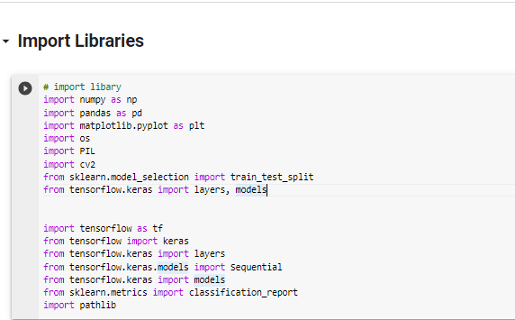

Figure 6. import Libraries

## **6.5.5 Import Dataset:**

In the second step, the chosen styles and the corresponding datasets used to train them are input into the system for prediction. This claim asserts that the "2D stage" is when the dataset is provided, which provides the data needed to train a system learning about fashions. The models may then be used to generate predictions after being trained on the dataset. The Dataset is one of the used public datasets that contains images. Here we highlight the fact that the dataset's learning models are fed input data in the form of photos that are likely connected to plants (in this case, rice leaves). The fact that this material may be found in the public domain raises the likelihood that it will be culled from a database. Leaf smut, brown spot, and bacterial leaf blight (helpful on Kaggle) are the three disease types that have been identified in this photograph. A similar phrase describes the form of the dataset here. Images of plant diseases are sorted by degree of severity. Leaves may suffer from "Leaf smut," "Brown spot," or "Bacterial leaf blight." Several different plant diseases with varying symptoms and names may be mentioned here. It has also been suggested that this dataset may be found on Kaggle, a website popular for hosting machine learning-related datasets and tournaments.

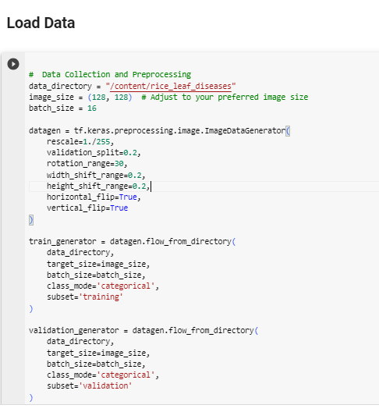

Figure 6. Import Data

## **6.5.6 Augmenting Data and Preprocessing**

The third stage includes access to preprocessing and data enhancement. Given the high cost of collecting unique data, an information augmentation strategy was used to increase the dataset's diversity in the field of education. This sentence explains that each preprocessing and information augmentation is blanketed inside the project. The want to have numerous datasets for successfully schooling gadget mastering fashions is emphasized inside the article. An approach known as information augmentation is used to provide this variety. Overfitting was reduced while the dataset size was increased by using techniques including flipping, zooming, and inverting the images. This statement defines the specific information augmentation methods that are used. Using these methods, we rotate and tilt photos at calculated angles. Images may be flipped horizontally or vertically. Images may be seen at various zoom levels. The brightness of the picture is changed. These methods make the dataset more chaotic and difficult to forecast. This is crucial because it allows device mastery models to generalize to new data with more ease if the dataset is bigger and more diversified. It is also emphasized that longer datasets provide less of a threat of overfitting, a phenomenon in which a model memorizes the training data rather than learning patterns. The algorithm's capacity for effective adaptation to new and uncharted situations is enhanced by this degree of enhancement.

## **6.5.7 Feature Extract:**

This phase discusses the architecture of the CNN version using Tensor Flow's Kera’s API. The version consists of three convolutional layers (Conv2D) with progressively larger filters (32, 64, and 128) and ReLU activation features. Utilizing three max-pooling layers (MaxPooling2D), the spatial dimensions can be down-sampled. Use a flattened layer to convert the 2D characteristic maps into a 1D vector. ReLU activation properties are included in two dense layers that are linked. Numerical elegance units, which correlate to the disease reputation classes, and a SoftMax activation feature are present in the remaining dense layer. Since there are multiple classes involved, the loss characteristic is sparse_categorical_crossentropy, and accuracy serves as the measurement for music education. The Adam optimizer is used to build the version. The version is trained using the training set (X_train and Y_train) for 20 iterations. Validation data (X_val and y_val) are used to measure the version's effectiveness while it is being learned. The professional version is categorized to determine the examination loss and examination accuracy using the validation data. The professional version is included in the report "rice_leaf_disease_model.h5". As a result, you could use the identified version to make predictions without having to retrain it.

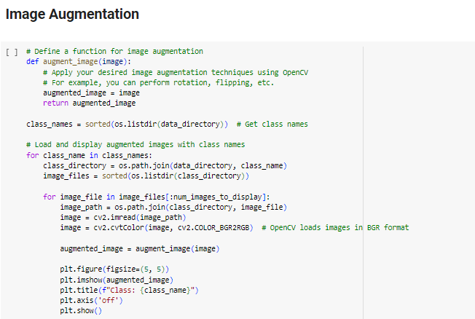

Figure 6. Image Augmentation

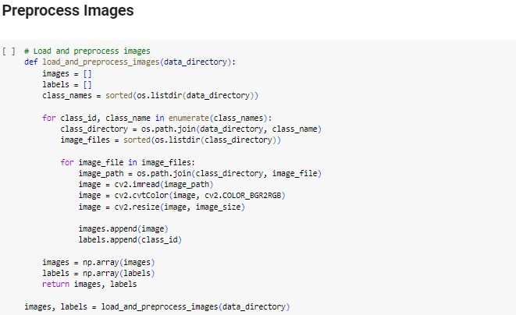

Figure 6. Preprocess Images

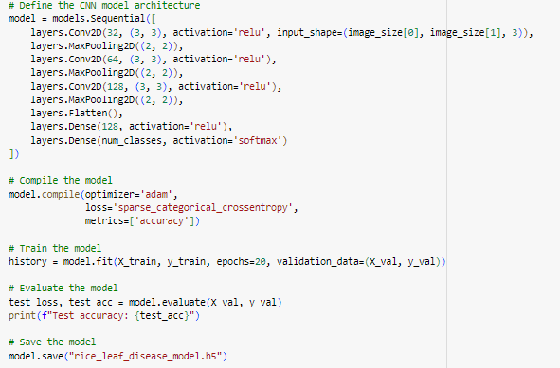

Figure 6. Feature Extraction

# **6.5.8 Save Feature:**

Based on this code, a new version of Kera’s is being built, and it will have an intermediate-layer model. This variant uses inputs that are comparable to those used by the original version (version. Input), and its activations in the second-to-last layer are replicated in its outputs (version. layers [-2]. output). This is accomplished with the use of the Model elegance included in the Kera’s model’s package. The intermediate_layer_model is tasked with predicting (i.e., activating) the intermediate layer outputs based on the training data X_train and the validation data X_val. The activations of the intermediate layer capture the representations of the information that have been found after it has been modified and processed by the neural community down to the precise layer. Finally, the functions of the intermediate layer are kept in NumPy binary documents called "train_features.npy" and "val_features.npy," for the training and validation datasets, respectively. When working with large multi-dimensional arrays and matrices, the Python package NumPy comes in handy. By documenting the functions in this way, they may be easily loaded and used for analysis, visualization, and the training of new device mastery models in the future.

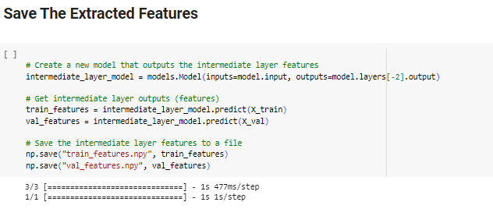

Figure . Save the Extracted Features

## **6.5.9 Data Splitting:**

The data are split into an education set and a validation set, and then the photograph records are used to provide the version with dimensions.

**Images:** This should be the entry records since it typically contains a lot of images in a language that your version can understand. Every image acts as a record element from which the model can learn.

**Labels:** The goal values or labels that correspond to the input photos are those. They serve as a substitute for the actual records that the collection of rules is trying to figure out how to predict.

**Test size:** This choice determines the size of the dataset that will be utilized for validation. In this example, the use of Test size=0.2 implies that 20% of the records can be used for validation and the remaining 80% for education.

Using the random state option, the random variety generator is seeded. To ensure the reproducibility of the records split, a particular value (inclusive of random state=42) may be set. After running this code, the following variables will be present:

**X_train:** The educational photo collection entered.

**X_val:** The collection of images used for entry validation.

**Y_train:** Corresponding labels for the education set. Labels that belong to the validation set are known as **Y_val.** The machine-learning version of you can then learn about and assess the utilization of those variables. By monitoring the version's performance on records that are no longer available for the duration of education, the validation set enables you to detect difficulties with over- or under-fitting. The version's settings are taught using the education set. 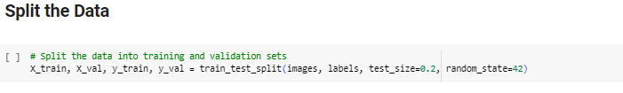

Figure .7 Split Data

## **6.5.10 Visualization of the dataset:**

Dataset's visualization, Create a bar graph using the dataset's three instructions. This bar graph can be used to visually depict the distribution of information factors across the three instructions. The number of information variables that are protected in that elegance will be reflected at the top of each bar. Using this type of visualization, you can more clearly observe how your dataset's instructions are distributed and any potential problems with class imbalance. The visualization of the SVM set of rules that results from three instructions is depicted in Figure 5.10.1. Bacterial leaf blight suggests excellent directions in those three instructions. Figure 5.10.2, on the other hand, shows how the KNN set of rules, which predicts outcomes from three instructions, looks like in practice. Random requirements for a forest are visualized in Figure 5.10.3, with bacterial leaf blight indicating the best outcomes. Figure 5.10.4 compares the outcomes of these three algorithms, showing that rules based on a randomly wooded zone get the best results overall.

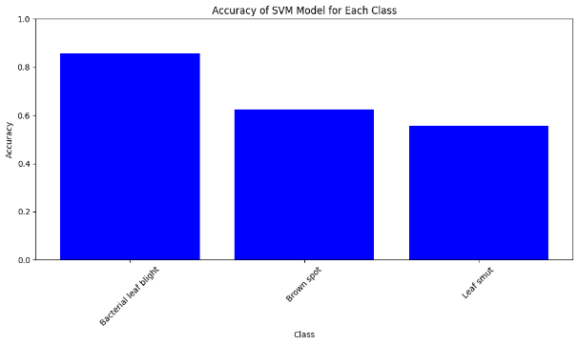

Figure .8 Accuracy graph support vector machine

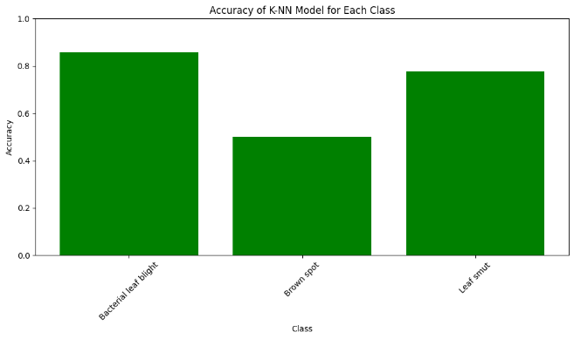

Figure .9 Accuracy graph K-Nearest Neighbor

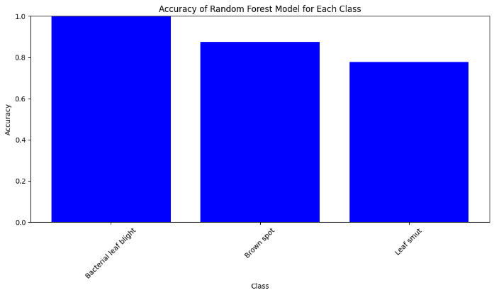

Figure .10 Accuracy graph Random Forest

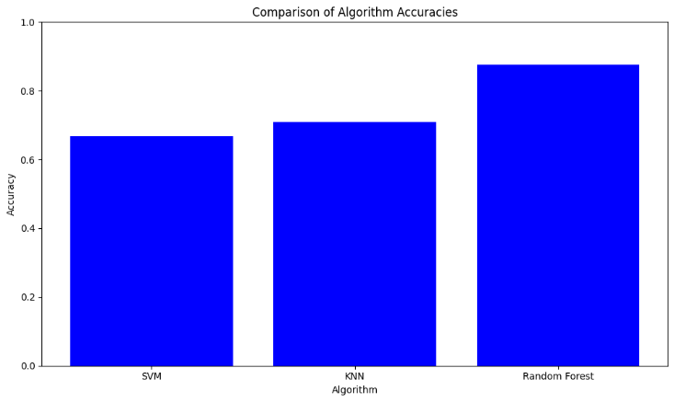

Figure .11 comparison accuracy

## **6.5.11 Efficiency Matrix**

When analyzing devices and gathering data on how effective a category version is, the confusion matrix is an essential tool. It's a simple technique to see how well a model is doing in terms of accurately identifying samples from different courses. A problem's data points (instances) may be broken down into several categories or lessons. The objective of a categorization version is to classify each prevalence according to its characteristics. Searching on the

Confusion Matrix, which separates the version's predictions and actual results, reveals where the version is delivering accurate predictions and where it is likely to make mistakes. Consider a "Confusion Matrix," which is a desk that illustrates and sums up the performance. It is simple to determine whether or not the machine is blending the lessons using the two labels "Predicted" and "True." The version's results on eye issues (covered throughout three lessons) are as follows on the heatmap and confusion matrix:

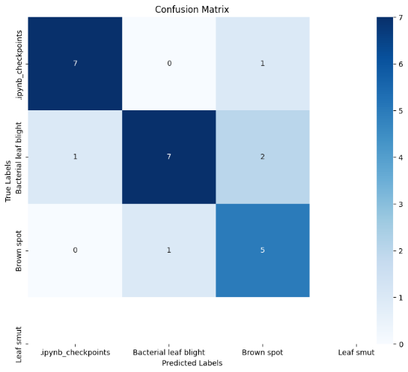

Figure .12 Performance of Support vector machine

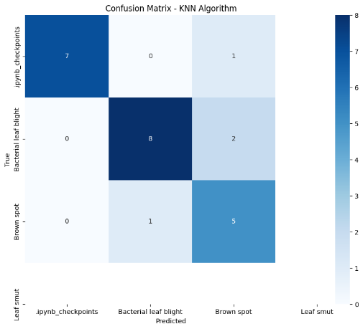

Figure .13 performance of K-nearest neighbor

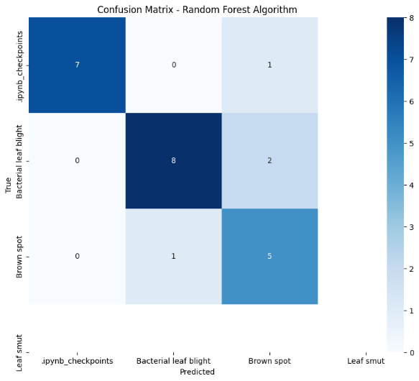

Figure .14 performance of random forest

## **6.6 Analysis of Model Performance**

Machine learning algorithms' effectiveness is measured in a variety of ways. We collect information by analyzing the current and future interplay between true positives (TP), false positives (FP), false negatives (FN), and true negatives (TN) a lack of assurance. A matrix table is often used to evaluate the efficacy of a classifier. Classification accuracy, sensitivity, specificity, F1-score, support, and area under the receiver operating characteristic (ROC) curve are the five metrics used to evaluate classifiers. The classification accuracy, or the percentage of properly categorized instances, is calculated using the parameters TN, FP, TP, and FN. Sensitivity measures how successfully diagnosed patients are.

**Accuracy:**

Specificity, also known as the true negative rate, quantifies the extent to which a classifier can identify and exclude non-positive occurrences. It is especially relevant when dealing with imbalanced datasets in which one class is much more numerous than the other. If you look at the model's specificity, you may learn about its capacity to identify incorrect events and make necessary adjustments.

$accuracy=\frac{correct predictions}{All prediction}$--------------------------------- (1)

**Precision:**

Precision is a key factor in determining how well a classification model performs, especially when false positives are a concern. It provides information on the accuracy of the optimistic predictions made by the model.

$Precision=\frac{True positive}{True positive+false positive}$------------------------- (2)

Let's dissect the elements of this equation:

**True Positives (TP):** They should belong there because the right class has been appropriately predicted in these situations. These individuals might, for instance, be patients who have been correctly diagnosed with a certain illness.

**False Positives (FP)** are cases when something is wrongly attributed to a group it does not belong to. In the field of medicine, for example, this may happen if the model falsely diagnoses an illness in an otherwise healthy patient. Accuracy refers to the frequency with which the version was correct in predicting an outcome (such as recovering from a particular sickness). The rate at which these events conform to norms is quantified. To rephrase, model accuracy is the rate at which correct predictions are produced. High-precision methods show that the model is usually true when it predicts a positive result. However, poor accuracy indicates that the model is incorrectly predicting many positive outcomes. Because false positives may have detrimental effects, accuracy is of the utmost importance. Misdiagnosing a healthy person as having a contaminant in a healthcare environment, for example, might lead to the patient undergoing unneeded treatments and additional stress. In this case, a more precise version will be necessary. However, remember that sensitivity and accuracy cannot coexist. It is common for diminishing accuracy factors to not forget to grow, and the converse to be true. The F1-score captures this trade-off by accounting for both types of accuracy to offer a balanced assessment of a classifier's efficacy.

**Recall:**

When it's crucial to keep track of every occurrence of positivity, despite the possibility of recording some false positives, recall, also known as sensitivity or the true positive rate, is an essential performance parameter in classification tasks.

$Recall= \frac{True positive}{True positive+false negative}$------------------------------ (3)

Dissecting the elements of this formula:

**True Positives (TP):** Since the relevant class has been correctly predicted in these conditions, they should belong there.

**False Negatives (FN)** These occurrences, while falling under a certain category, are incorrectly predicted to no longer fall under that category. Recall focuses on cases that fall into a class (such as people with a particular illness) and measures the percentage of these instances that the version accurately anticipated. Simply put, recall refers to how the model was able to accurately recall some of the truly fantastic moments. The version has an excessive forget when it successfully captures the majority of the great activities contained within the dataset. However, excessive forgetting will also be accompanied by a rise in false positives or incidents that are incorrectly classified as positive. This is the don't forget as opposed to precision trade-off. In instances wherein forgetting wonderful activities has significant repercussions, don't forget is in particular crucial. For instance, failing to perceive a real case of a disorder for the duration of a scientific analysis may also cause the remedy to be not on time and the affected person's results to worsen. You could need a version with precise don't forget in such instances. In the end, the choice of whether or not to prioritize don't forget, or precisely relies upon the precise context and outcomes of fake positives and fake negatives. In a few instances, you would possibly use measures just like the F1-score, which takes under consideration each precision and don't forget, to attempt to attain stability among the two.

**F1- Score:**

A statistic known as the F1-score combines recall (sensitivity) and precision into a single value. Precision is the proportion of precisely predicted positive cases among all cases that were expected to be positive. Recall (sensitivity) is the proportion of correctly predicted positive events among all positive instances. By accounting for both false positives and false negatives, the F1 score provides an accurate assessment of a classifier's performance. It's especially beneficial when you're trying to balance memory and precision. If you wish to obtain great precision and good memory, a high F1 score is preferred.

$F1=\frac{2(P*R)}{P+R}$-----------------------------------------------------(4)

**Comparing Classifiers:** When comparing the effectiveness of two distinct classifiers, accuracy, specificity, and F1-score might provide useful information. When dealing with unbalanced datasets, accuracy may not be the best measure of total correctness because it only gives a broad perspective of the situation. Specificity is advantageous when it comes to detecting bad instances. The F1 score achieves a harmonious balance between precision and recall. But it's important to keep in mind that not every case lends itself to the usage of a single statistic. The exact goals of your application will determine the metric you employ. For instance, it may be crucial to prioritize sensitivity (recall) when making a medical diagnosis to discover as many positive cases as possible, even if doing so increases the number of false positives. In some situations, precision may be more crucial.

### **6.7 Results and Findings:**

Table 6.1 shows the outcome when three distinct models are used. All models provide the maximum possible precision. Random Forest is the most effective learning and testing method.

Table . Results of Model

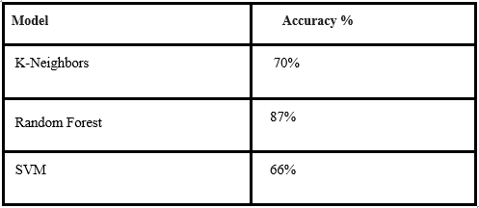

**Performance Validation:**

The accuracy and potency of our strategy are demonstrated by the models' evaluations of their overall performance. The Support Vector Machine (SVM) method improved its accuracy to around 66.67%, demonstrating its ability to recognize patterns in the dataset. The K-Nearest Neighbors Classifier (KNN) proved its capacity to detect inconspicuous similarities and differences inside the function space with an improved accuracy of around 70.83%. With an impressive 87.5% accuracy, the Random Forest ruleset easily beat all the other options. This demonstrates how well it works in locating subtle connections within the dataset. By contrasting the findings from various precision evaluations, we may establish which rule sets are more beneficial. In light of this, it's clear that picking the right set of rules is crucial. The ensemble-based nature of the Random Forest set of rules makes it better at capturing complicated relationships than the SVM and KNN algorithms, which both concentrate on pattern recognition.

**Revealing Insights:** Our investigation yielded invaluable details regarding the habits and performance of each algorithm across several categories as we looked deeper. The confusion matrices made it easy to weigh the pros and cons of various strategies. The Random Forest technique in particular has shown its ability to manage complex data by producing accurate and balanced predictions across several classes. On the other hand, the SVM and KNN algorithms relied on class-specific features, showing that they were sensitive to those characteristics. These findings, which extend beyond simple accuracy measures, illuminate the interconnected webs of classifications, algorithms, and dataset characteristics. This research provides a thorough understanding of the algorithmic behaviors, including their benefits and drawbacks, and serves as an essential reference for picking new models and enhancing existing ones.

This phase's in-depth research and careful analysis of its findings therefore perfectly encapsulate the essence of our undertaking. These findings guide future activities and provide validation for strategic choices made throughout the model selection and implementation processes. These insights equip us to refine, optimize, and deploy our models in practical agricultural settings, where they may have a greater impact. This chapter lays the groundwork for a comprehensive system for recognizing and categorizing rice leaf illnesses, which will be the outcome of a thorough investigation of our data.

# **Chapter 7: Critical Analysis**

In this chapter, we critically assess our project by analyzing its initial aims, how closely we stuck to the plan, and the invaluable lessons we learned.

# **7.1 Evaluation against Objectives:**

The success of our project is gauged by the initial goals we set out to attain. The main goal we had was to develop an effective model for the detection and classification of rice leaf diseases to solve problems specific to the agricultural sector. Several metrics, such as accuracy scores and confusion matrices, were used to assess the quality of the model. The algorithms we tested had varying degrees of success; the Random Forest method, with an accuracy of 87.5%, stood out as the most promising because of its capacity to capture intricate relationships.

**7.2 Review and Plan Deviations:**

Because data science initiatives are dynamic, certain changes occurred even though our project mainly adhered to the original plan. The complexity of the dataset was underestimated in the initial timeframe, necessitating a minor extension of the preprocessing and data-gathering phases. However, this modification allowed for a deeper understanding of the data, which improved the model's performance. The iterative nature of algorithm selection and tuning, which took longer than anticipated, necessitated a revised timetable. These small adjustments emphasize the importance of adaptability and a realistic assessment of project phases.

**7.3 Lessons learned:**

We learned invaluable lessons that have advanced our understanding of data science and its practical applications at every stage of the project.

**Flexibility in planning:** The project's dynamic nature brought to light the importance of adaptable planning. Accepting minor differences resulted in better outcomes and a deeper understanding of challenges and possibilities.

**Algorithmic Suitability:** The disparities in algorithmic correctness brought to light the importance of selecting algorithms on the task's complexity. This serves as a reminder that there isn't a single approach that solves all data science issues.

**Data preparation and exploration:** Careful data preparation and exploration are the cornerstones of model performance. The initial effort put into understanding the dataset pays off in the form of accurate and reliable models.

**Interdisciplinary Insight:** By collaborating across disciplines, such as data science and agriculture, we were able to make groundbreaking findings. The project's overall quality was raised, and collaboration was encouraged. Knowledge gaps were also filled. Data science is a field that is always evolving, as shown by the research. Practitioners need to stay updated and open to new information because algorithms, methodologies, and best practices are constantly evolving.

**Application in Actual Life:** The transition from developing models to deploying them in the actual world highlighted the importance of durability and efficiency. For real-world deployment, it is frequently required to optimize for both accuracy and processing effectiveness. This rigorous evaluation supports the success of our project, both in terms of the results and the lessons discovered along the road, in conclusion. The project's congruence with goals, agility in planning, and capacity for overcoming challenges confirm the project's viability. The knowledge and understanding we have attained, as well as the lessons we have learned, will undoubtedly affect our future endeavors in data science and other fields.

# **Chapter 8: Conclusions and Future Work**

By developing a detection tool and suggesting precautions for farmers, this study aims to address the problem of infections in rice leaves. The study's scope extends to the illnesses caused by Leaf Blight, Leaf Blast, and Brown Spot. To help farmers recognize these diseases and advise actions they may take to decrease their consequences, the aim is to provide a practical answer. Farmers and agriculturalists can easily diagnose diseases that affect rice plants using the provided method. This is done by allowing users to post photos or take pictures of rice leaves. This method makes disease diagnosis easy and available to people involved in agriculture.

The idea has the potential to greatly increase the income and output of farmers. Convolutional Neural Network (CNN) models have been trained to analyze images, and this research is no exception. Transfer learning is used to adapt a previously learned model for use in categorization. By expanding the existing body of information, the researchers enhanced the accuracy of the pre-trained model in identifying diseases in rice leaf samples. The results of the investigation point to successful outcomes. Across all test scenarios, the model's overall accuracy percentage is 87%. This degree of accuracy suggests that the model is successful in classifying cases of various rice leaf diseases. Even while it is not flawless, an accuracy of 87% is nevertheless remarkable, especially given the complexity.

### **Review and State-of-the-Art Comparison:**

The findings of our study provided a workable method for classifying and diagnosing rice leaf diseases. Through several steps of data collection, preprocessing, algorithm selection, and training, we were able to achieve impressive accuracy; the Random Forest method proved to be the most successful, with an overall accuracy of 87.5%. This finding agrees with the most recent advances in the field, and it represents a significant step forward in the fight against illness in farming. Through in-depth analysis of several methodologies, including algorithms and augmentation procedures, we were able to strengthen our model's robustness.

### **Ethical, Legal, Social, and Professional Considerations:**

Using models in actual-world circumstances raises several ethical, legal, societal, and professional considerations, including the following:

**Privacy and Data Security:** Collecting and retaining agricultural data requires stringent security measures to safeguard farmers' information and prevent misuse.

**Bias Mitigation:** It is crucial to ensure that the model is not biased against any certain demographics or groups to detect diseases properly.

**Transparency:** Enabling users to see and understand the model increases their trust in it and helps them to understand how decisions are made.

**Intellectual property:** It is important to establish clear guidelines for who owns the model, data, and outcomes while taking partnerships and contributions from different stakeholders into account.

**Impact on Farming Communities:** Although technology is helpful, it should be applied while taking into account the particular demands, customs, and economic realities of farming communities. The diagnosis of agricultural illnesses has significantly improved thanks to our technological conclusion. By incorporating state-of-the-art AI techniques, our model is now competitive with the state-of-the-art alternatives. The trip was highlighted by in-depth research, careful assessment, and insightful conclusions, all of which have improved our understanding of the function of data science in solving practical problems. There are numerous chances for advancement and progress as we look to the future, even though a clear commitment to moral and responsible AI is necessary to reflect our commitment to both scientific achievement and societal well-being.

# **References**

A. Jayakumar. (2021). Detection and Classification of Leaf Diseases in Maize Plant using Machine Learning MSc Research Project Data Analytics. *agriculturegoods.com*.

A. Parikh, M. S. (2016). Disease detection and severity estimation in the cotton plant from unconstrained images. *3rd IEEE International Conference on Data Science and Advanced Analytics*, 594–601.

A., R. M. (2015 ). Groundnut leaf disease detection and classification by using a back propagation algorithm’,. *International Conference on Communications and Signal Processing*.

Ahmed, K. S. (2019). Rice leaf disease detection using machine learning techniques. *International Conference on Sustainable Technologies for Industry 4.0*.

Ahmed, K. S. (2019). Rice leaf disease detection using machine learning techniques. *In *2019 International Conference on Sustainable Technologies for Industry 4.0*.

Hasan, M. J. (1-6). Rice disease identification and classification by integrating support vector machine with deep convolutional neural network. *In 2019 1st international conference on advances in science, engineering and robotics technology*.

Hasan, M. J. (2019). Rice disease identification and classification by integrating support vector machine with deep convolutional neural network. *2019 1st international conference on advances in science, engineering and robotics technology (ICASERT)*, 1-6.

Jayakumar, A. (. (n.d.). Detection and Classification of Leaf Diseases in Maize Plant using Machine Learning MSc Research Project Data Analytics. *https://agriculturegoods.com/why-is-agriculture-important/*.

Kawcher Ahmed, T. R. (2019). Rice Leaf Disease Detection Using Machine Learning. *2019 International Conference on Sustainable Technologies for*.

Lu, Y. Y. (2017). Identification of rice diseases using deep convolutional neural networks. *Neurocomputing*.

Lu, Y. Y. (2017). Identification of rice diseases using deep convolutional neural networks. *Neurocomputing*, 378-384.

Mahalakshmi, S. a. (2020). Pest and disease detection for corn field using image analysis. *Journal of Ambient Intelligence and Humanized Computing*, 7375–7389.

Mahalakshmi, S. H. (2021). Convolutional Neural Network for Skull Recognition. *International Journal of Innovative Computing*.

Matin, M. M. (2020). An Efficient Disease Detection Technique of Rice Leaf Using AlexNet. *Journal of Computer and Communications*.

Matin, M. M. (2020). An Efficient Disease Detection Technique of Rice Leaf Using AlexNet. *Journal of Computer and Communications*.

P. Sharma, P. H. (2020). Classification Of Plant Leaf Diseases Using Machine Learning And Image Preprocessing Techniques. *10th International Conference on Cloud Computing, Data Science & Engineering (Confluence), Noida, India*, 480-484.

Ponnusamy, V. e. (2019). Automatic robotic crop disease detection and pesticide dispenser using machine learning. *Journal of Advanced Research in Dynamical and Control Systems,* 119–125.

R Salini, A. F. (2021). Pesticide Suggestion and Crop Disease. *semanticscholar.org*, 9015-9023.

Ramesh S, V. D. (2019). Recognition and Classification of Paddy Leaf Diseases Using Optimized. *Information Processing in Agriculture*, 249–260.

Ramesh, S. &. (2018). Rice blast disease detection and classification using a machine learning algorithm. *In 2018 2nd International Conference on Micro-Electronics and Telecommunication Engineering*.

Ramesh, S. H. (2018). Plant disease detection using machine learning. *International conference on design innovations for 3Cs computes communicate control (ICDI3C)*, 41-45.

S. Pavithra, A. P. (2019). Paddy Leaf Disease Detection Using SVM Classifier. *International Journal of communication and computer Technologies*.

shima Ramesh, M. R. (2018). Plant Disease Detection Using Machine Learning. *2018 International Conference on Design Innovations for 3Cs Compute Communicate Control*.

Shrivastava, V. K. (17- 26). Rice plant disease classification using colour features: a machine learning paradigm. *Journal of Plant Pathology*.

Shrivastava, V. K. (2019). Rice plant disease classification using transfer learning of deep convolution neural network. *International Archives of the Photogrammetry, Remote Sensing & Spatial Information Sciences.*

Shrivastava, V. K. (2019). Rice plant disease classification using transfer learning of deep convolution neural network. *International Archives of the Photogrammetry, Remote Sensing & Spatial Information Sciences*.

Vaishnnave, M. P. (2019). Detection and classification of groundnut leaf diseases using KNN classifier. *In 2019 IEEE International Conference on System, Computation, Automation and Networking*, 1-5.

Vaishnnave, M. P. (2019). Detection and classification of groundnut leaf diseases using KNN classifier. *2019 IEEE International Conference on System, Computation, Automation and Networking*, 1-5.

Wen-Liang Chen, Y.-B. L.-L.-Y.-W. (2020). Rice Blast Detection using Internet of Things and Artificial Intelligence Technologies. *IEEE Internet of Things, 7*, 1001–1010.

Zekiwos, M. &. (2021). Deep Learning-Based Image Processing for Cotton Leaf Disease and Pest Diagnosis. *Journal of Electrical and Computer Engineering*.

Zekiwos, M. &. (2021). Deep Learning-Based Image Processing for Cotton Leaf Disease and Pest Diagnosis. *Journal of Electrical and Computer Engineering*.